Insertando imagen...

ACME-SF

G1.007

**Planning and progress report**

14/2/2024



# Cover

|  |  |
| --- | --- |
| **Repository:** <https://github.com/DP2-C1-07/Acme-SF-D01> | |
| **Student #1**  **ID:** 31878881F  **UVUS:**  pabcabmar3  **Name:** Caballero María, Pablo **Roles:** manager, developer | **Student #2**  **ID Number:**49034820Q  **UVUS:** mararnmon  **Name:** Arnáiz Montero, Marco Antonio  **Roles:** developer, operator |
| **Student #3**  **ID Number:** 77865211E  **UVUS:**  alfalolan  **Name:** Alonso Lanzarán, Alfonso Luis  **Roles:** developer, tester | **Student #4**  **ID Number:** 53932912M  **UVUS:** albsanmim  **Name:** Sánchez Mimbrero, Alberto  **Roles:** developer |
| **Student #5**  **ID Number:** 48123111G  **UVUS:** juagarcar4  **Name:** Garcia Carballo, Juan  **Roles:** developer |  |

Table of contents

Cover 2

Executive summary 2

Revision table 2

Introduction 3

Contents 3

Planning chapter: 3

Progress chapter 5

Conclusions 5

Bibliography 5

# Executive summary

The lifecycle of the Acme-SF project just started. Thus, it is currently in its first stages: the repository has recently been set up and minor changes have been made. Most of the time spent in this deliverable was for having the first contact with the technologies asked, preparing the workspace, analyzing the WIS requirements and fulfilling the required documentation.

# Revision table

|  |  |  |
| --- | --- | --- |
| Number | Date(dd/mm/yyyy) | Description |
| 1.0 | 15/02/2024 | Document done in its entirety |

# Introduction

The purpose of this document is to provide a detailed planning and progress report of the first delivery of the project “Acme-SF-D01”, for the subject “Design and Testing 2”. This is divided into two chapters: planning (specifying the requirements set for this delivery, assignees, roles, planned time, actual time, budget estimation...) and progress (assignees performances, conflicts arisen, actual cost in contrast to the estimations...). This document has an executive summary, a revision table where there are versioned records, this introduction, the main content (divided in a planning, and a progress chapter), and the conclusions of the report.

# Contents

## Planning chapter:

List of taks for the first deliverable:

|  |  |  |  |  |
| --- | --- | --- | --- | --- |
| Title and description | Assignees | role | Estimate | Invested time |
| Task S01-003/M2: Produce a planning and progress report | Pablo-Caballero-Maria | developer | 40 | 50 |
| Task G-001/M: Customise starter | Pablo-Caballero-Maria | developer | 30 | 36 |
| Task 015: Attend to classes | Pablo-Caballero-Maria | developer | 720 | 720 |
| Task G-004: Create organization repository | Pablo-Caballero-Maria | manager | 10 | 15 |
| Task S01-002/M1: Produce an analysis report | Pablo-Caballero-Maria | developer | 30 | 10 |
| Task G-004/M: Produce a planning and progress report | Pablo-Caballero-Maria | manager | 120 | 160 |
| Task S1-001/F: Modify the anonymous menu | Pablo-Caballero-Maria | developer | 10 | 20 |
| Task 031: Create tasks | Pablo-Caballero-Maria | manager | 30 | 60 |

Next, there are screenshots that shows different moments of the delivery development.

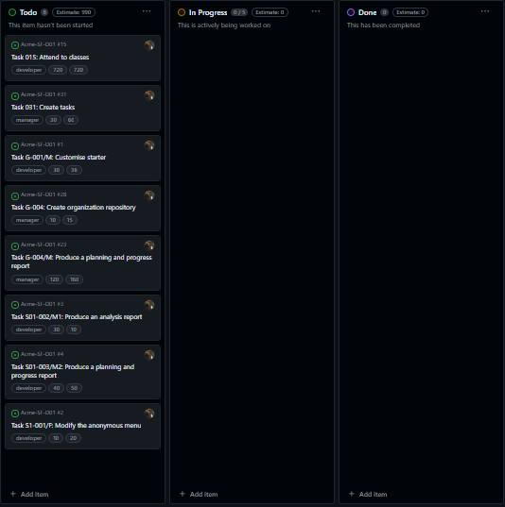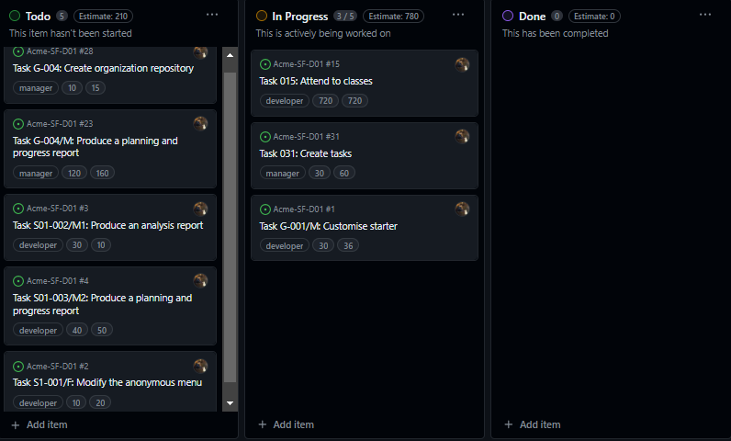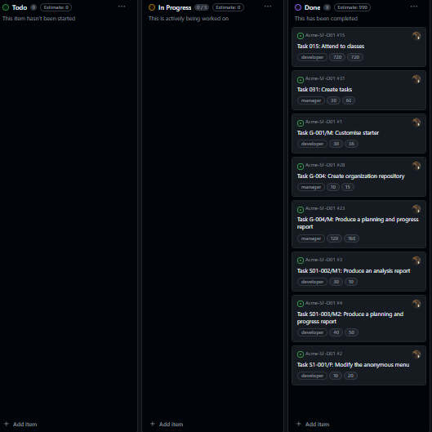

Next, it is shows the calculation of the estimated budget:

|  |  |  |  |  |  |
| --- | --- | --- | --- | --- | --- |
| Title and description | Assignees | Role | Estimate (minutes) | Cost/minute (euros) | Total/task  (euros) |
| Task S01-003/M2: Produce a planning and progress report | Pablo-Caballero-Maria | developer | 40 | 0.33 | 13.2 |
| Task G-001/M: Customise starter | Pablo-Caballero-Maria | developer | 30 | 0.33 | 9.9 |
| Task 015: Attend to classes | Pablo-Caballero-Maria | developer | 720 | 0.33 | 237.6 |
| Task G-004: Create organization repository | Pablo-Caballero-Maria | manager | 10 | 0.5 | 5 |
| Task S01-002/M1: Produce an analysis report | Pablo-Caballero-Maria | developer | 30 | 0.33 | 9.9 |
| Task G-004/M: Produce a planning and progress report | Pablo-Caballero-Maria | manager | 120 | 0.5 | 60 |
| Task S1-001/F: Modify the anonymous menu | Pablo-Caballero-Maria | developer | 10 | 0.33 | 3.33 |
| Task 031: Create tasks | Pablo-Caballero-Maria | manager | 30 | 0.5 | 15 |

Total cost for tasks = 353,93 €

Equipment cost = 700 €

Considering a lineal amortization over 3 years, the yearly amortization cost is 351,31 €

## Progress chapter

Progress records:

Member: Pablo Caballero María

Performance indicators: since the assessment of the lecturer is subjective and could not be complete due to the fact that the project was not completed when it was reviewed, we will focus on the objective performance indicator defined in the chartering report. Thus, total tasks done/total tasks to do ratio is 1, which is considered “good” according to the aforementioned report. Along these lines, I will be granted the privilege to choose the role for the next delivery.

No conflicts whatsoever arose during the progress of this delivery.

Next, there is a table showing the actual budget consumed by the project:

|  |  |  |  |  |  |
| --- | --- | --- | --- | --- | --- |
| Title and description | Assignees | role | Invested time (minutes) | Cost/minute (euros) | Total/task (euros) |
| Task S01-003/M2: Produce a planning and progress report | Pablo-Caballero-Maria | developer | 50 | 0,33 | 16,5 |
| Task G-001/M: Customise starter | Pablo-Caballero-Maria | developer | 36 | 0,33 | 11,88 |
| Task 015: Attend to classes | Pablo-Caballero-Maria | developer | 720 | 0,33 | 237,6 |
| Task G-004: Create organization repository | Pablo-Caballero-Maria | manager | 15 | 0,5 | 7,5 |
| Task S01-002/M1: Produce an analysis report | Pablo-Caballero-Maria | developer | 10 | 0,33 | 3,3 |
| Task G-004/M: Produce a planning and progress report | Pablo-Caballero-Maria | manager | 160 | 0,5 | 80 |
| Task S1-001/F: Modify the anonymous menu | Pablo-Caballero-Maria | developer | 20 | 0,33 | 6,6 |
| Task 031: Create tasks | Pablo-Caballero-Maria | manager | 60 | 0,5 | 30 |

Total cost for tasks = 393,38 €

Equipment cost = 700 €

Considering a lineal amortization over 3 years, the yearly amortization cost is 364,46 €

Comparing, we can calculate that yearly cost would be a 3,74% higher than the cost that was estimated.

# Conclusions

The planning of tasks was done using GitHub projects. Since I was assigned the role of “manager”. I have learned how to work more efficiently for the next deliverables, in terms of creating the tasks and exporting them to include them in the present report. Additionally, since I am now more familiar with how much time some tasks take, I think I will be able to estimate the time better for the next sprint.

# Bibliography

Intentionally blank.